§
‘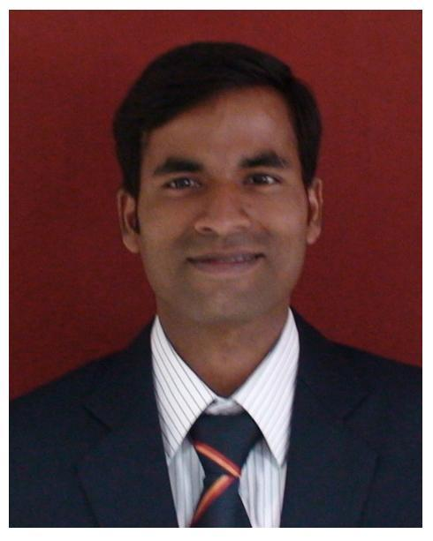’’’’’’’’’’’’’’’’’’’’’’’’’’’’’’’’’’’’’’’’’’’’’’’’’’’’’’’’’’’’’’’’’’’’
PRASANTA KUMAR PRADHAN
Mobile: +91-8328942321 | E-Mail: kontactprashant@gmail.com

SENIOR PROFESSIONAL – Banking& Finance
An upbeat leader with a passion to deliver extensive managerial & financial skills and the natural aptitude to identify & capitalize upon opportunities for maximizing sales and optimizing company benefits ~

ǁ PROFILE SUMMARY ǁǁǁǁǁǁ

- A competent professional with over 10 years of experience in Banking Operations, Sales & Marketing, Business Development and Client Relationship Management
- Competency in managing branch operations and implementing strategies towards enhancing market penetration, business volumes and growth
- Deepened strong rapport with HNI clients to win confidence, anticipate needs and deliver appropriate product solutions with proven record in achieving targets and opening new & profitable product/services markets
- Expertise in managing entire business development activities, analyzing market trends and establishing healthy & prolonged business relations with clients, thereby ensuring higher market share
- Ensured implementation of Policies, Standards & Procedures, and regulatory requirements; strong knowledge of Anti Money Laundering and conducting examination of financial fraudulent activities
- Excellent communication, training, presentation and people management skills that have been honed through managing cross-functional teams

ǁ AREAS OF EXPERTISE ǁǁǁǁǁǁ

Business Development Team Management Audit & Compliance
MSME Funding and Asset servicing Branch Administration Risk Control
Client Relationship Management Banking Operations Report Preparation.

ǁ WORK EXPERIENCE ǁǁǁǁǁǁ

From 2009 – till date: ICICI Bank Ltd., Cuttack

Key Result Areas Across Growth Path

Apr’17 - till date: Manager-BLG (MI)

- Responsible for MSME funding, New Business acquisation and Team management.
- Handling 5 branches of ICICI Bank at Cuttack for MSME business loan.
- Acquisition of new business, Renewal and servicing of business loan ranging from 1Mn to 300Mn.
- Managing portfolio of 300Mn business
- Responsible for Whole business cycle processing of working capital and short tern loans.
- Responsible for Dedupe ,Financial Analysis, EDD, KYC, Legal and valuation process of of BLG clients.
- Functional Training of branch team members.
- Customer Indentification, Balancesheet Analysis, nal.

May’14 – Mar’17: Risk Manager (MI)
- Facilitated risk management, internal & external audits by compliance and implementation of processes as per norms of various regulatory bodies
- Attended and resolved the audit findings by reviewing, tracking, monitoring & self-auditing the various branch records
- Steered compliance, operations risk monitoring, fraud prevention and IAD audit of different branches of the bank
- Tracked high value suspicious transactions in account &conducted enhanced due diligence (fraud analysis) of those accounts
- Gained exposure on Anti-Money Laundering, KYC and RBI Guidelines to mitigate the operational risk
- Created, communicated and ensured adherence to department risk policies, procedures and best practices
- Reassessed existing processes and created new ones that could effectively anticipate, manage and reduce risk

May’12 – Apr’14: Branch Operations Manager(DMII)
- Lead branch business along with operations for about 6 months in the absence of Branch Manager
- Supervised customer centric banking operations, forwarded instructions to the concerned department and ensured customer satisfaction by achieving delivery & service quality norms
- Implemented business generation plans & policies for attainment of targets by appointing associates
- Maintained customer database to improve tracking, reporting and customer service
- Organized cross functional trainings within &across branch teams about relevant processes and regulations for audit and compliance; re-engineered key shortcomings in existing processes to achieve 98% service quality levels and 0 customer escalations
- Reduced cost of the branch by approximately 10% through process reengineering of cash management

Aug’10 – Apr’12: Branch Sales Manager(DMI)
- Monitored branch banking operations and managed servicing for HNI Clients
- Targeted new acquisition and CASA incremental on YOY basis
- Facilitated institutional banking for cooperative banking
- Led Sales Team for cluster for NCA acquisition, DSB for cooperative banks, financial planning for HNIs and development of asset business

Feb’10 – Jul’10: CSM(AM)
- Checked all banking transactions put through by the assistants and reconciled the accounts of the branch, cash flow management, increased deposit base of the branch and maintained good customer relationship
- Conducted operational risk analysis on clearing settlement process
- Led all kinds of settlement process carried out by the branch
- Built healthy business relations with clients and ensured high customer satisfaction matrices by achieving delivery & service quality norms

Significant Accomplishments
- Certificate of excellence received from Zonal risk head for FY2016-17
- Got appreciated by Zonal Head for highest YOY CASA Mobilization in 2012
- Bagged “Eagle Eye Award” Twice for preventing fraud for the year of 2011 & 2012
- Won “The Best Operations Manager” Award and appreciated for attaining 5 Star Internal Audit conducted by the Audit Committee of the Bank in 2013
- Succeeded in managing new client’s portfolio in excess of INR 7.5 Billion with annual revenue exceeding INR 10 Crores
- Ramped up the client satisfaction score by above 90% through regularly interacting with clients and ensuring that queries and escalations were addressed on time
- Managed customer service operations, ensured customer delight by achieving delivery & quality service within TAT

ǁ ACADEMIC DETAILS ǁǁǁǁǁǁ

- PGDM from Manipal University, Bangalore in 2009 with 70%
- B.Sc. from Utkal University, Bhubaneswar in 2006 with 55%

ǁ CERTIFICATIONS ǁǁǁǁǁǁ

- Trained banker on MSME funding by CRISIL EXECUTIVE TRAINING programme, New Delhi.
- CAIIB from Indian Institute of Banking & Finance, Mumbai in 2016
- JAIIB from Indian Institute of Banking & Finance, Mumbai in 2013
- Certified Banker by Indian institute of Banking and Finance, Mumbai
- AMFI- Mutual Fund (Advisors) Module, NCFM
- IRDA-Agency module, Indian School of Insurance

ǁ PERSONAL DETAILS ǁǁǁǁǁǁ

Date of Birth: 9thJuly 1985
Languages Known: English, Hindi, Oriya and Marathi
Address: C/o Batakrushna Pradhan, D/224, Sector -7, Cuttack,753014,Odisha
Passport No.: N4508681

I hereby declare that all the information mentioned above is true to the best of my knowledge.
Place: Cuttack, India
Date: 22-10-2019 Prasanta Kumar Pradhan

